1 Patient I want to receive pressure alert System alerts patient when high-pressure regions are detected .
User
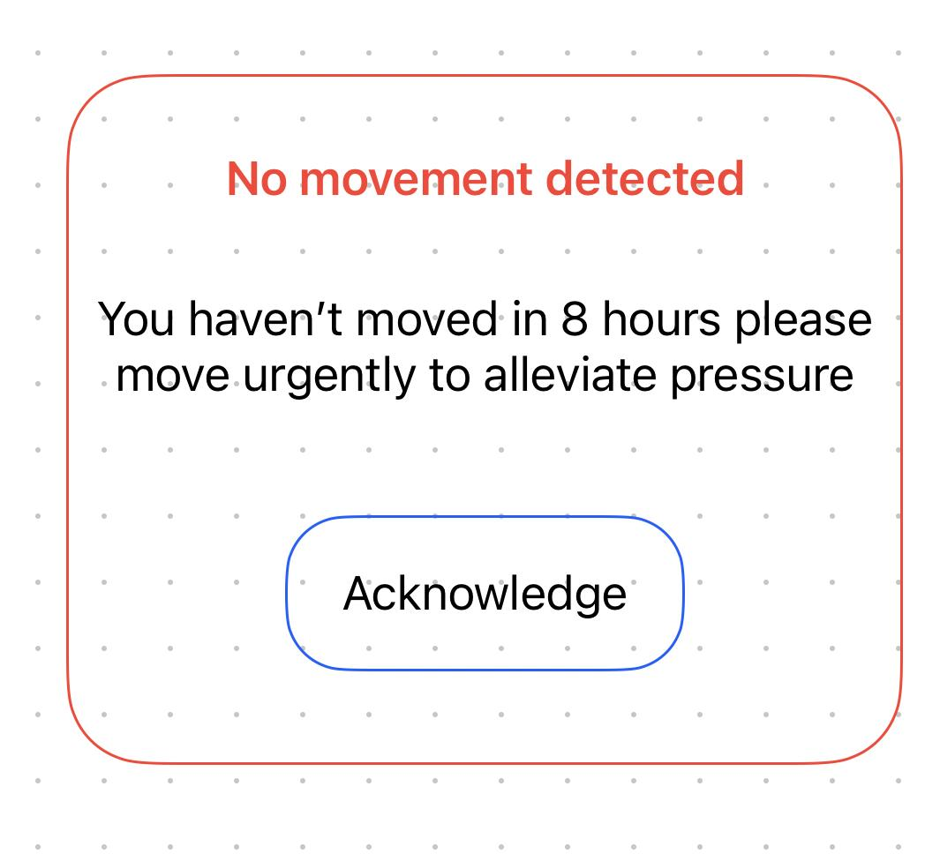

2 Clinician: I want to receive no-movement alert Notifies clinician if patient hasn’t moved for 8+ hours
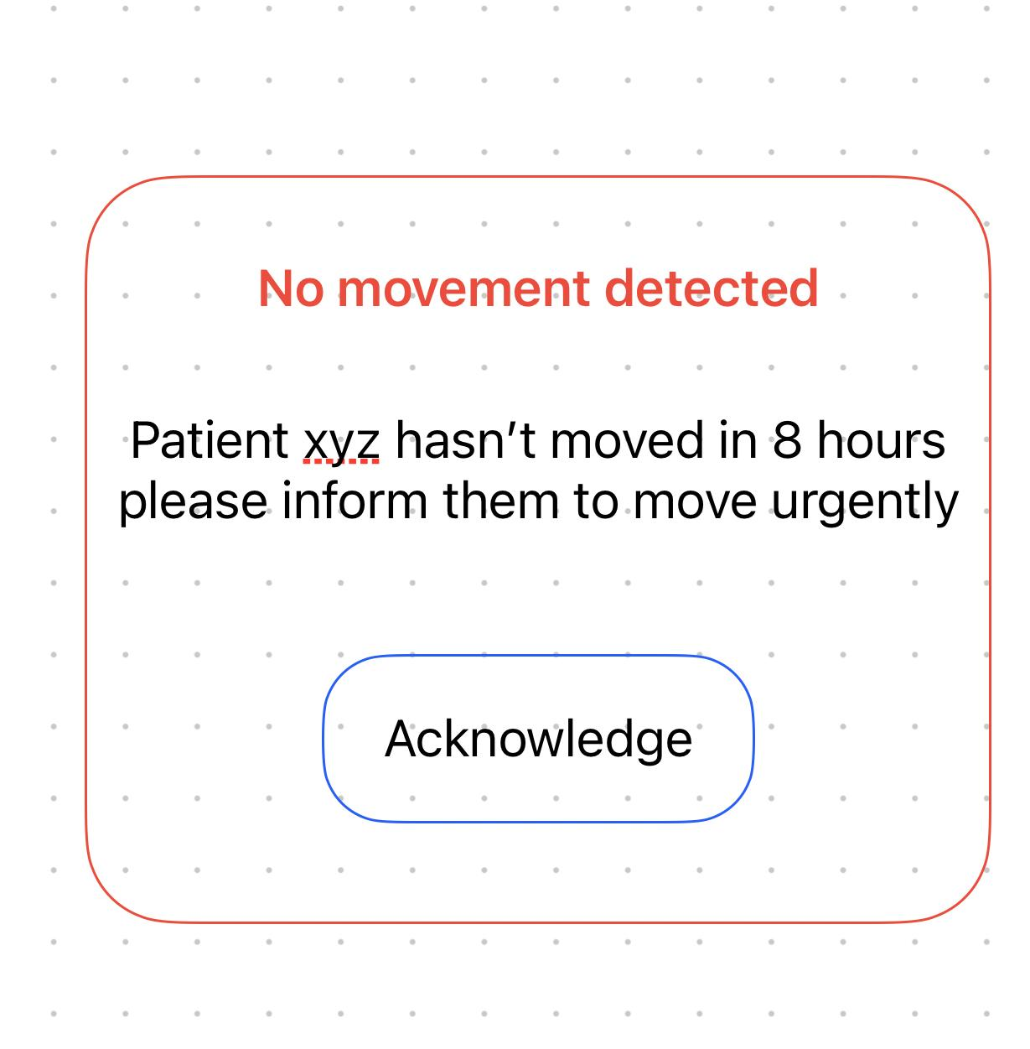
3 Clinician: I want to be able to analyse low-movement areas View report showing regions with minimal pressure variation so I can better understand patient issues,
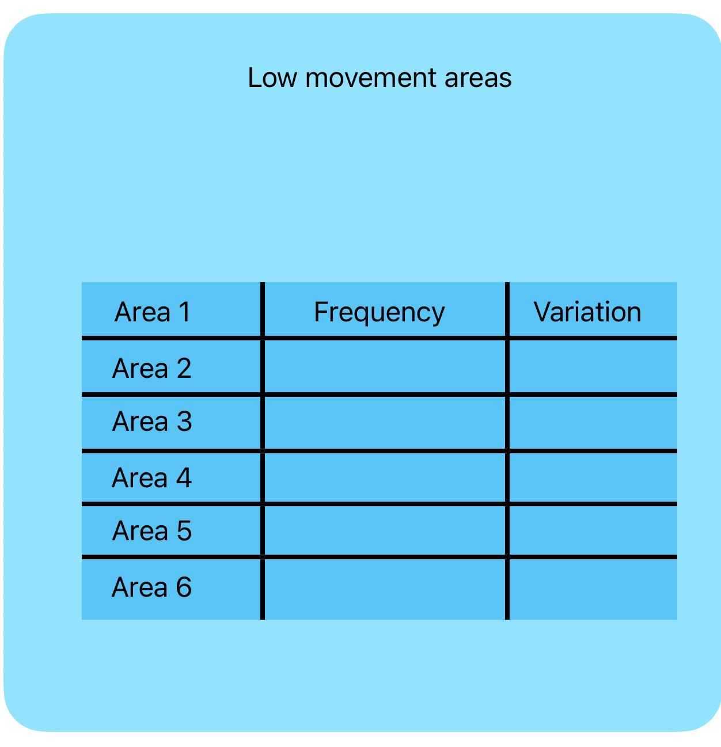

4 Clinician: I want to see maps of regions which are frequently not moved often to better monitor and provide care
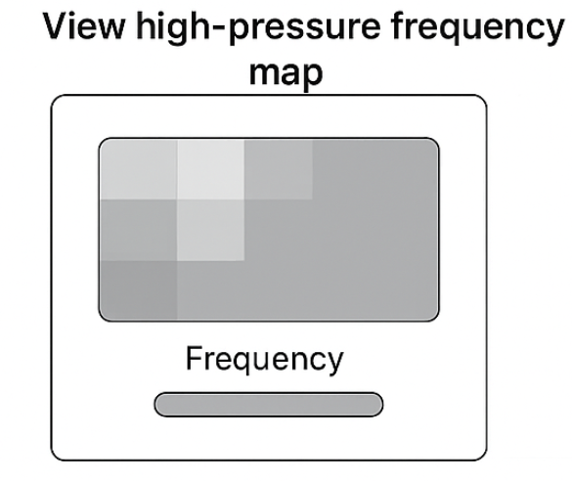

5 Admin: I want to manage users and permissions Add/remove users and control which clinicians/devices can access data
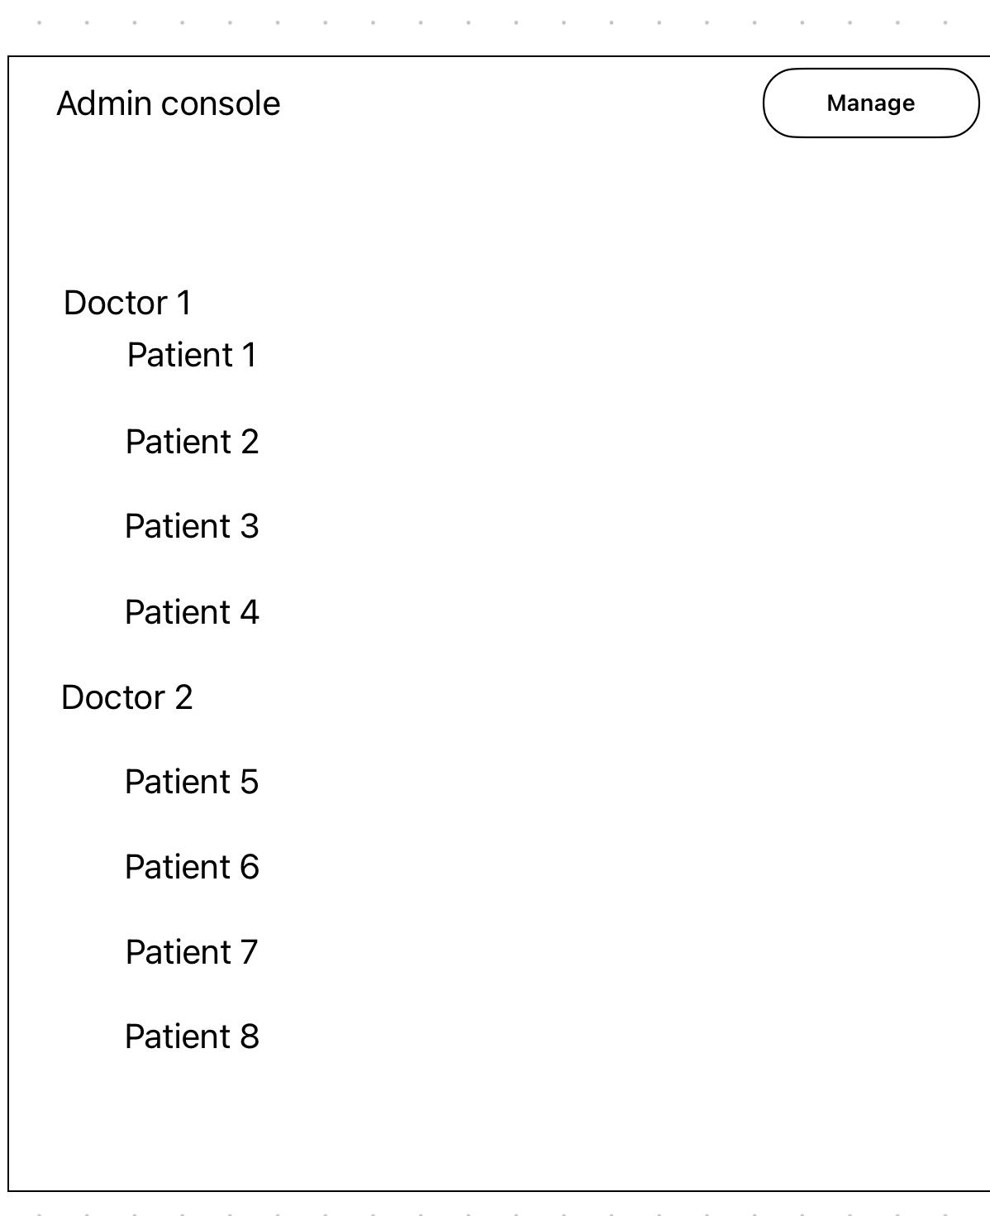

6 Clinician: I want to respond to patient comments View and reply to feedback submitted by patients

